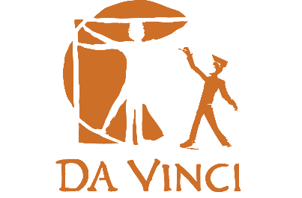
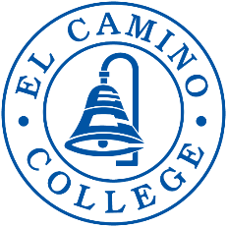
Fall 2022
Community College
Course Opportunity

Who: Rising Juniors and Seniors from DVC, DVD, and DVS
What: College courses at Da Vinci, through El Camino College. Courses meet transfer requirements for all Cal State and UC campuses, as well as most private colleges and universities.
Why: Get a jump on your college credits! If you do well, it also looks great on your college applications.
Cost: Free! The state of California and Da Vinci Schools pick up the costs, including textbook fees. Donations to help cover the cost of the textbooks for families that are able to are appreciated.
Where: : Classes will be held virtually and are synchronous on canvas, the El Camino College student portal.
BUS 101 (BUS 25)- Intro To Business  (Synchronous Class) | POLI 1- Governments of US & CA  (Synchronous Class)
This course is a survey of organization and management factors influencing the establishment, location, and operation of businesses. This course emphasizes the functional area of accounting as well as the legal framework within which business activities are conducted. The course also emphasizes the principles of Total Quality Management (TQM) in a multicultural and globalized environment.  3 units; 3 hours lecture  Transfer CSU,UC  Tuesdays & Thursdays from 3:30pm - 4:55pm  Start Date: Tuesday August 30th, 2022 | This course is a survey of the concepts, theories, and functions of the American political system. The basic principles of the United States Constitution and the government of California will be examined. Emphasis will be placed on the formal and informal influences of federalism on national and state governments. *Note: Some UC transferable courses have credit limitations. For details, see a counselor, the Transfer Center adviser, or the articulation officer.  3 units; 3 hours lecture  Transfer CSU, UC  Mondays and Wednesdays from 3:00pm - 4:25pm  Start Date: Monday August 29th, 2022

If you are interested please see your college counselor to sign up. Please note that these are college courses, taught by college instructors. All students must show their counselor and administrators the academic skills and accountability necessary to be in these courses. Students must abide by the college policies, including regarding absences and tardies.

